Partner Portal – www.profitcomm.com/partnername

Section One: Service
- Audit – Playbook For Audit (one with MSP one without)
- Service Checklist – Everything we do
- Pathfinder Login

Section Two: How To
1.Playbook on how to get started
- IQA links – Scope Builders
- E mail
Section Three: Resources
- Cobranded Material
- Videos
- Case Studies
- Solutions by Vertical
Section Four: Partnership
- Agreements
- Commissions
- Funnel

Partner Service Portfolio
Managed IT/Help Desk (remove for MSPs)
Security
UCaaS/Hosted VOIP/Microsoft Teams
CCaaS/Contact Center
Cloud – Public, Private, Hybrid
Network/SD WAN
Internet Circuits – Primary, Secondary, Tertiary
Wireless – Cell, Tablets, IOT, Sensors, Internet
POTS Migration/Replacement
Technology Expense Management and Asset Tracking
Disaster Recovery/Back Up
Desktop as a Service
Colocation/Data Center
CPaaS – Managed SMS platforms and mass notification
Energy – Procurement, Efficiency Consultation, Solar, Electronic Vehicle Chargers
AI and Automation – Contact Center, Video Cameras, Security as a Service
Marketing – Outsourced Social Media/Marketing/CRM
Gamification and Employee Productivity
Virtual Reception and Tier 1 Support
Healthcare – Outsourced TeleHealth, All in One Office, EMR
ERP – Oracle, SAP, SalesForce and ServiceNow Implementation and Management
Outsourced Databased Administration

Managed IT/Help Desk

Summary of Services
Managed IT/Help Desk is using a third party company to handle some or all of the day to day IT services for an organization. They will push out proactive patches and updates to keep the environment healthy and they are also available to call for break/fix scenarios. They usually install an agent on the machines that allow them to remote in to fix whatever issue arises. Here are some of the things they can support:
-Microsoft Suite, Google Suite
-PCs, laptops, servers, firewalls, switches, routers, Wireless Access Points, etc…
-Software, hardware, firmware
-security – malware, MDR/EDR

Prelude
Key vendors in the ProfitComm portfolio (Logos)


Ancero Ntiva

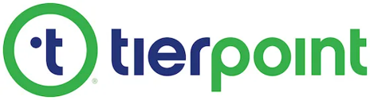
CentricsIT

Tierpoint

Dataprise

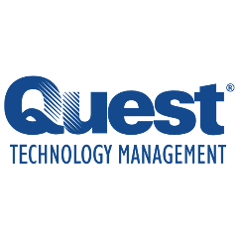
Thrive
Quest Technology
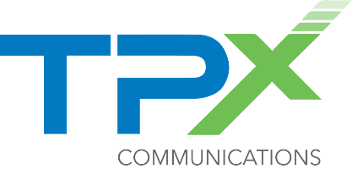

TPx
Managed SolutionsNotes:
Some vendors charge per person, some change per device.
Help Desk Questionnaire
ProfitComm Telecommunications Help Desk
ProfitComm Telecommunications Managed Services

Security
Summary of Services
Security is becoming a very important part of every customer’s technological landscape. The need is being driven by the constant news of security breaches, exponential rise of cyber security insurance policies, and potential reputational damage. The best policy is a proactive approach to protecting your environment. We view security costs on a scale of $ to $$$$

Vendors that support the framework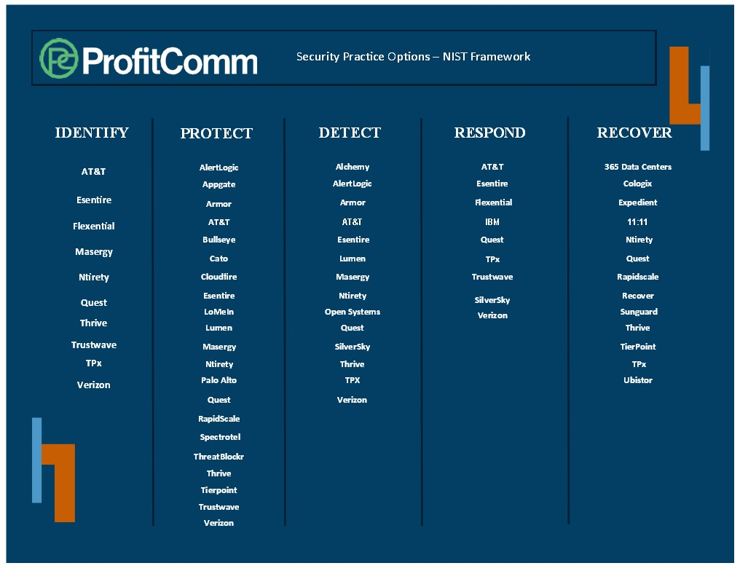
Notes: new vendors are being added monthly and we offer vendor agnostic security engineering resources to help on calls and demos
Security Questionnaire Links
ProfitComm Telecommunications Security
ProfitComm Telecommunications Healthcare Security

UCaaS/Hosted VOIP

Summary of Services:
UCaaS is not only cloud telephony, but fully unified communications. Phone, SMS, Chat, E Mail, video and collaboration tools make up the full UCaaS experience. Connect using physical VOIP phones, computer softphones, and or mobile apps to be reachable anywhere. Integrations with CRMs, Microsoft Teams and databases allow for ease of use and enhanced productivity.
Supported Vendors:
There are over 75 UCaaS vendors in the portfolio but these are some of the key providers
8x8 BCN CallTower CommandLink Consolidated Comcast
Dialpad Fusion Connect Lingo MetTel Lumen
Ring Central Simplicity VOIP Spectrotel TPX Vonage Zoom






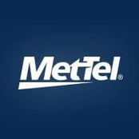

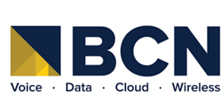

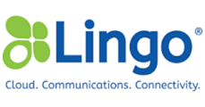
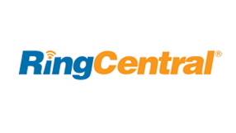

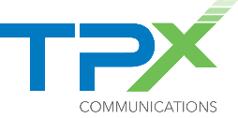


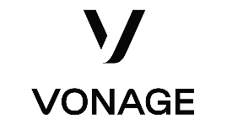


Notes: The best experience comes from understanding the customer’s entire environment so we can only engage the select vendors that are going to best meet the customer’s needs. ProfitComm offers complimentary vendor agnostic UCaaS/Hosted VOIP Sales Engineering resources for calls and demos.
ProfitComm Telecommunications UCaaS
ProfitComm Telecommunications UCaaS: Microsoft Teams

CCaaS/Contact Center as a Service

Summary of Services:
Contact Center is an omni-channel communications platform that encompasses voice, SMS, chat, video, e mail. Most CCaaS solutions have ntegrations with CRM, ERP, and other database solutions. AI and automation allow for improved customer engagement, customer experience. In addition to the platforms themselves, there are other contributing solutions such as gamification, productivity enhancements, workforce management/workforce optimization, etc…

ProfitComm has over 75 Contact Center vendors in the portfolio. Below are some of the key players
8x8 Broadvoice CallTower Dialpad Five9
Fusion Connect Genesys Nice Ring Central Simplicity VOIP
TalkDesk UJet Vonage




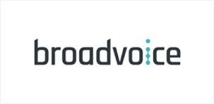
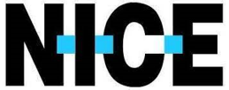
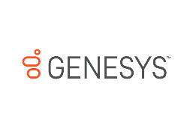






Notes:
ProfitComm’s vendor agnostic engineering specialists are exceptional at creating custom solutions for customers.
Dialpad’s AI offers agent coaching cards and CSAT scores on EVERY SINGLE CALL, saving supervisors 10-20% of their time back that they would normally be listening to call recordings to give their agent ratings. Game changer in the industry.
ProfitComm Telecommunications Contact Center as a Service

Cloud – Public, Private Hybrid

Summary of Services:
Cloud computing is a general term for anything that involves delivering hosted services over the internet. These services are divided into three main categories or types of cloud computing: infrastructure as a service (IaaS), platform as a service (PaaS) and software as a service (SaaS).
A cloud can be private or public. A public cloud sells services to anyone on the internet. A private cloud is a proprietary network or a data center that supplies hosted services to a limited number of people, with certain access and permissions settings. Private or public, the goal of cloud computing is to provide easy, scalable access to computing resources and IT services.
Cloud infrastructure involves the hardware and software components required for proper implementation of a cloud computing model. Cloud computing can also be thought of as utility computing or on-demand computing.
ProfitComm has over 100 vendors that offer some sort of cloud solution. Below are the key players:
11:11 Systems Ancero Claro Data Canopy
Dataprise Evoque Expedient Ntirety
OTAVA Quest Technology Management Rackspace RapidScale
Sky Data Vault TierPoint Thrive TPx
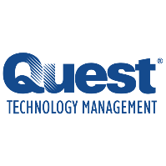

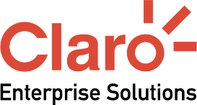
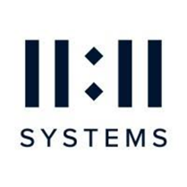




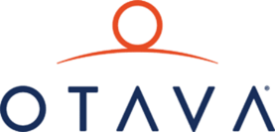
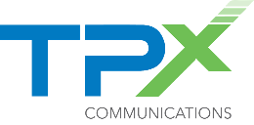







Notes:
ProfitComm Telecommunications Managed Public Cloud
Network/SD WAN/SASE
Summary of Services:
Networks connecting offices are growing exponentially as the need for bandwidth is becoming insatiable. Companies that once had active/passive MPLS connections are rapidly migrating to SD WAN for enhanced performance and cost efficiencies. Many network vendors are offering enhanced security at the edge called SASE as a fully managed solution.

ProfitComm has over 100 vendors who offer enhanced network solutions. These are the key players.

ACC Business AT&T BCN Cato CBTS
Cogent Comcast CommandLink Cox
HyperCore Lumen MetTel NetWolves Nitel


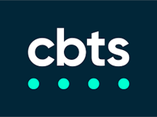
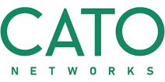
Spectrotel Spectrum TPx Verizon ZeroOutages



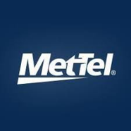







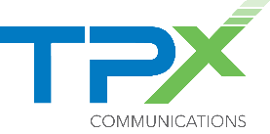


Notes:
Aggregators like CommandLink, MetTel, NetWolves and Spectrotel offer solutions from many underlying providers that can be managed from a single pane of glass.
CommandLink should be considered in every network deal, they are that good.

ProfitComm Telecommunications SD-WAN & SASE

Internet Circuits – Primary, Secondary, and Tertiary

Summary of Services:
Internet circuits are a mandatory solution for every business. Cloud based solutions have made it so that virtually all businesses must have at least two redundant ISP options for always on connectivity. Internet solutions can be fiber, coax, or wireless.

ProfitComm has over 100 provider that supply some sort of internet connectivity. Here are some of the major players:
ACC Business AT&T BCN Cato CBTS
Cogent Comcast CommandLink Cox
For2Fi OneRing Networks Sierra Wireless Ready Wireless
Lumen MetTel NetWolves Nitel Spectrotel
Spectrum TPx Verizon ZeroOutages
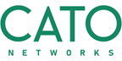


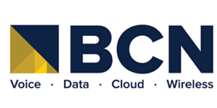


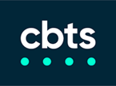





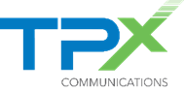







Notes:
Aggregators offer the ability to streamline invoicing so that the customer does not get a bill for every single location.

Wireless – Cell, Tablets, IOT, and Sensors

Summary of Services:
Corporate cell plans offer a better way to control costs and management of wireless devices across an organization. Mobile devices communicating with one another offers visibility into inventory, device health, and many other critical data points. Staging, kitting, warehousing, and decommissioning devices can be outsourced to the vendors rather than bringing the time-consuming tasks in house.



Below are some of the key vendors in this space.
AT&T
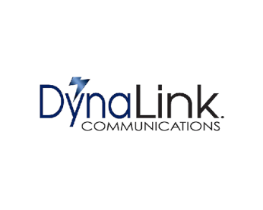
Dynalink
KORE

MetTel

Metro Wireless

Modas

T Mobile

Verizon
Vodaphone

Notes:
Modas, MetTel and KORE offer omni-SIM solutions that ride multiple networks for best performance.
Modas, MetTel and KORE offer enhanced warehousing, staging, and kitting solutions

ProfitComm Telecommunications Mobility

POTS Replacement

Summary of Services:
Incumbent LECs have been trying to shut down analog networks for years. The FCC agreed to let them sunset the traditional copper facilities for fiber and wireless. Telcos will not just shut them off, they will raise the price and force you to do something else. Many POTS Replacement options are devices deployed on site that connect with one or dual SIM LTE wireless cards or over WIFI. The analog fax, alarm, credit card, and/or elevator lines are then ported into the device and routed over WIFI or LTE. Cost savings in some cases can be astronomical. The only thing sexy about analog lines is that they are going away and many customer still need to connect those devices somehow.

ProfitComm Vendors that play well in this space:
BCN Lingo HyperCore
MetTel Spectrotel VCom Momentum
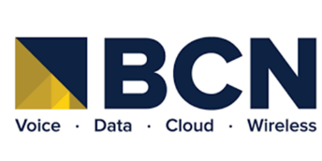
NHC Optimum Business Ooma TPX

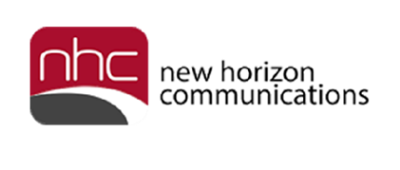



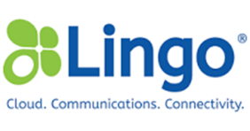



Notes:

Technology Expense Management

Summary of Services:
TEM providers are typically third-party providers that help business financial and operational personnel manage any vendor where there is monthly cost or annual subscription or license. Instead of “the guy with the spreadsheet”, you get a single pane of glass for all technology inventory, spend management, invoice processing, contracts, moves/adds/changes, orders, and contract negotiations.
Services Included:
- Telecommunications
- VOIP/Contact Center
- ISPs/Networks
- Wireless
- Cloud – public, private, hybrid
- Data Center/Colocation
- Licenses/Certificates

Vendors Included (logo)
-Warner Telecomm -VMox - Calero
-Tangoe -Wireless Watchdogs -Advantix
-Sakon -Brightfin -Expense Reduction Analysts
-VCom -Tellennium -Schooley Mitchell
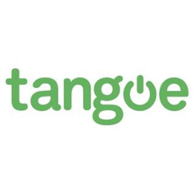



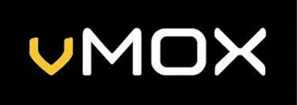


Notes:
Warner Guarantees 150% of their cost in savings or they pay you the difference
ERA and Schooley Mitchell are contingency based solutions where they take a percentage of savings, and they include more than just technology solutions

ProfitComm Telecommunications Telecom Management

Disaster Recovery/Back Up Solutions

Summary of Services:
Disaster Recovery and Back Up as a Service offer businesses the peace of mind to know if servers crash or if bad actors try to hold a business hostage, you can get your business back up and running. Back ups are typically charged based on the frequency and size of the data being backed up. DR typically are charged based on Recovery Point Objective (RPO) and Recovery Time Objective (RTO). RPO typically refers to how much data loss a company can sustain without significant harm while the RTO refers to the amount of time a business can afford to lose before harm. The more real time a business needs, the higher the cost.

Some Key Vendors Offering these services.
11:11 Systems Ancero AT&T C Spire
Claro Cologix Consildated DartPoints
Data Canopy Effortless Expedient Flexential
Lunavi Ntirety OTAVA Performive
Rackspace RapidScale Sky Data Vault Thive
Tierpoint TPX

Notes:

ProfitComm Telecommunications Backup & Disaster Recovery

Desktop as a Service/VDI

Summary of Services:
Desktop as a Service (DaaS) and Virtual Desktop Infrastructure (VDI) provide remote access to desktop environments and applications. VDI hosts desktops on centralized servers in a data center, with users accessing via the Internet. DaaS, a cloud service, allows users to access virtual desktops hosted by a third-party provider, offering scalability and cost savings. Both eliminate the need for physical workstations and enable secure, flexible access from multiple devices​.

Some Service Providers That Play well here

Ancero Dizzion Effortless Lunavi
Managed Solution Performive Thrive TPX

Notes:

ProfitComm Telecommunications Desktop as a Service

Colocation/Data Center Solutions

Summary of Services:
Colocation data centers allow businesses to rent space for their IT hardware, providing necessary resources like power, cooling, and security. This service is a cost-effective alternative to owning and operating a private data center, offering scalability and enhanced security. Businesses can choose from different space options such as cabinets, cages, or private suites, depending on their needs​.

Vendors well Suited for this service
365 Data Centers Claro Cologix Coresite
Cyxtera Data Canopy Databank Equinix
Evoque Expedient Flexential INAP
Lunavi Netrality OTAVA Perfomive
QTS Rackspace RapidScale TierPoint

Notes:

ProfitComm Telecommunications Colocation

Communications Platform as a Service and Mass Notification Systems

Summary of Services:
Communications Platform as a Service (CPaaS) is a cloud-based delivery model that lets you add voice, video, and messaging features to your existing business software using APIs.
CPaaS allows you to cherry-pick real-time communications features and embed them into your apps and services. It’s attractive to growing companies who already use a cloud-based technology stack and want to customize their communications infrastructure.

A mass notification system (MNS) is a platform that sends one-way messages to inform employees and the public of an emergency.

Vendors that play well in this space
Everbridge Sinch Bubble by Broadvoice Intelipeer
Simplicity Speakap

Notes:

ProfitComm Telecommunications General Inquiry

Energy – Procurement, Efficiency Consultation, Solar, Electronic Vehicle Chargers

Summary of Services:
Organizations can lower their energy consumption through strategic procurement solutions as well as consultations with experts. Electric charging stations are becoming must have items for customers to serve their customers and employees who have electronic vehicles.

Vendors who Can Help Here

Abundant IOT
Modas Systems
GHA Technologies
Expense Reduction Analysts

Notes:
The Modas solution has an advertising component to it that generates revenue, shortens the ROI, and effectively monetizes the parking lot.

AI and Automation – Contact Center, Video Cameras, and Security as a Service

Summary of Services:
Solutions that use AI and Automation to achieve performance enhancement, improve customer experience and customer satisfaction, and process improvement.

Contact Center- AI can help coach agents for better outcomes, automate agent proficiency scoring, gauge sentiment, and self help scenarios for improved customer experiences.

Dialpad Observe AI Level AI LiveVox Talkdesk Ujet Vonage Yellow AI

Video Cameras – AI can help intelligently source video cameras and video footage

Comm-Core Claro YourSix

Security and A Service – using AI to learn your infrastructure so it can be protected

Coro SilverSky

Notes:

Marketing – Outsourced Social Media, Marketing and CRM

Summary of Services:
These companies can outsource marketing, social media content and posting, as well as customize CRM platforms so companies do not have to hire full time employees to support these functions.

Vendors that play here

Ready For Social Thryv Weave Kustomer

Notes:

Gamification and Employee Productivity

Summary of Services:
Hiring good employees is challenging and keeping them is even harder. Post Covid, businesses are struggling to gauge the productivity of their employees, keep them trained, elevate performance levels and reduce burnout.

Vendors that play well in this space:

Prodoscore
HeydayNow
Olumo

Notes:

Virtual Receptionist and Tier 1 Support

Summary of Services:
Outsourced call handling can help organizations meet the demand of calls being answered with less Full Time Employees doing the actual work. Outsourced Tier 1 support allows for organizations to hire top level IT talent and have those team members focusing on higher priority scenarios rather than password resets.

Vendors that play well in this space:

Ruby
Answer Hero
Peacey Systems

Notes:

Healthcare Specific Solutions – TeleHealth, All in one Office, Electronic Medical Records and Remote Monitoring

Summary of Services:
Healthcare has specific needs due to compliance and the nature of patient care. Whether it is branded telehealth, remote patient monitoring, all in one solutions for the complete physician/patient experience, or EMR, we have them covered. All these solutions are HIPAA and PCI compliant.

Vendors that play well here:

Markee
Weave
NetWolves – VasoHealthcare
KORE Connected Care
GHA Technologies

Notes:

ERP – Oracle, SAP, SalesForce, and ServiceNow Implementation and Management

Summary of Services:
Outsourced implementation and Management of ERP Solutions.

ProfitComm vendors that can play here:

RTS
GHA Technologies

Outsourced DataBase Administration

